Sept 2nd , 2012
Dear Colleagues,

PAYTON is moving.

As you all know, Payton’s vision is to lead the Planar Technology worldwide, to be the preferred technology within the magnetic world. This vision sets ongoing challenges to provide unique and creative engineering solutions and to improve Payton’s products quality and production yield, while offering our customers with prompt and comprehensive service and support.

In order to meet these challenges, alongside the blessed increasing volumes of production and Payton’s endless efforts to improve the company operating efficiency, we have decided to consolidate ALL Payton’s operation sites in Israel under ONE roof - the new “PAYTON HOUSE”. The new building is built, designed and owned by Payton, to meet our present and future needs.

We are pleased to announce that in the beginning of 2013, all Payton’s activities – The Planar components operation, the Conventional components operation and Payton’s PCB plant will be moving to the new Payton House in Ness- Ziona, Israel. This location is in an industrial zone, close to main highways and to the international airport and is only about 20km from our existing facilities.

We trust that this move to the new Payton House, will enhance maintaining Payton’s products superb quality, while improving the production conditions, the internal communication, the logistic operation and as a result, it will further improve our customer service, of which we are very proud of.

Looking forward for your continuing cooperation and assistance,
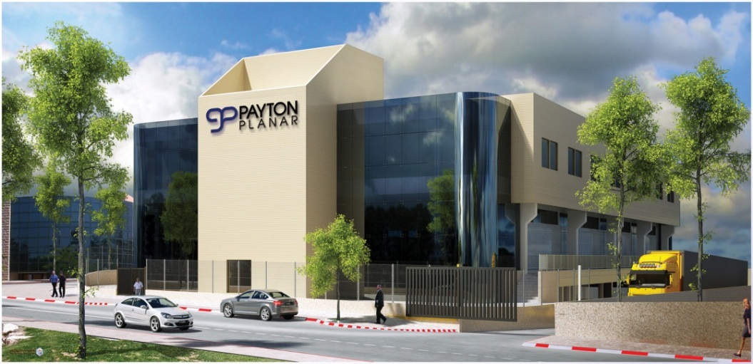
Doron Yativ
CEO

